Retail Sales Analysis

1. Project Overview
This project analyzes retail sales data to understand customer purchasing behavior and business performance. Using Python, SQL, and Power BI, the data is cleaned, analyzed, and visualized to identify:
- Sales trends
- High-performing categories
- Customer segments
- Peak sales periods
The insights support data-driven decisions to improve revenue, profitability, and overall business strategy.

2. Dataset Summary
- Rows: 2,000
- Columns: 11
- Key Features:
  - Customer Demographics: Age, Gender
  - Sales Details: Product Category, Quantity Sold, Price Per Unit
  - Financial Metrics: Cost of Goods Sold (COGS), Total Sale, Profit
  - Transaction Information: Transaction Date, Transaction Time
- Missing Data:
  - Missing values in Age, Quantity, Price Per Unit, COGS, and Total Sale columns
  - Missing Age values handled using mean imputation
  - Rows with missing critical numeric values were removed during data cleaning

3. Exploratory Data Analysis using Python
Data Preparation and Cleaning:
- Imported dataset using Pandas
- Explored data with df.info() and df.describe()
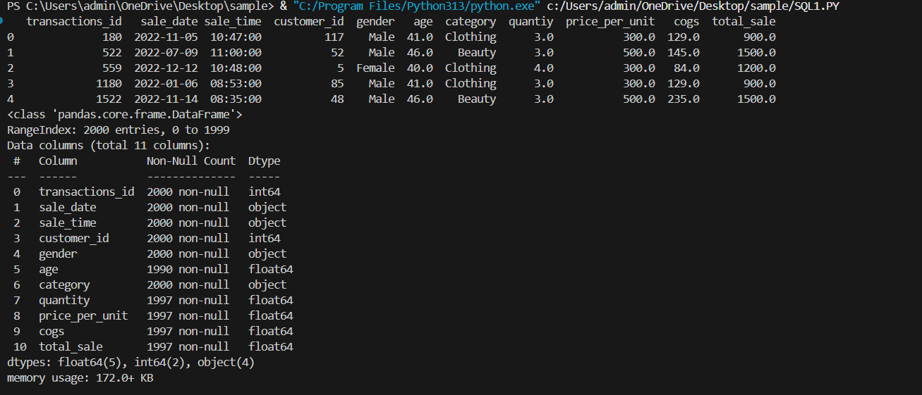
- Handled missing data:
  - Filled missing Age values with mean
  - Removed rows with missing critical numeric values
- Validated data for duplicates and consistency
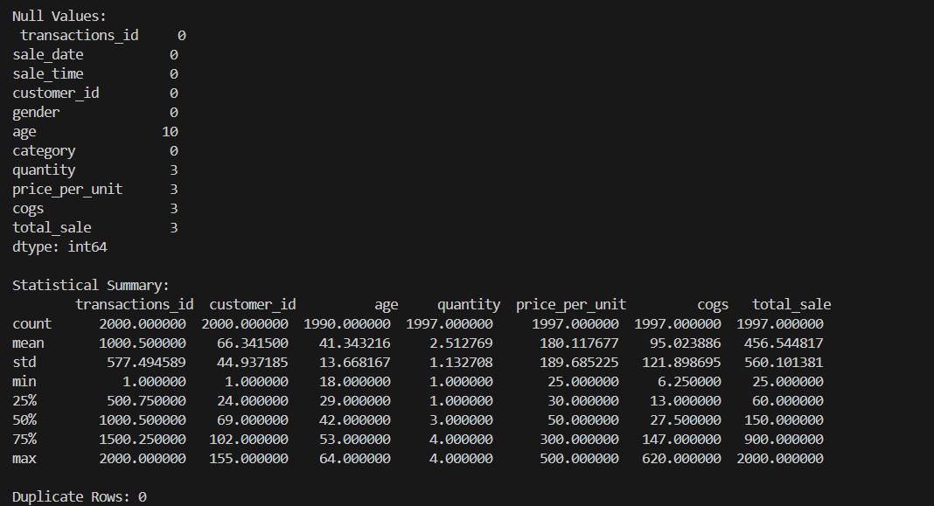
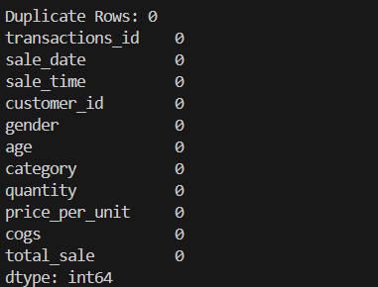
- Standardized and renamed columns for clarity
- Exported cleaned dataset for SQL analysis and dashboard visualization

4. SQL Analysis & Insights
Age Group Analysis
- Created age buckets: 18–25, 26–35, 36–45, 46–60, 60+
- Identified age groups generating highest revenue and profit
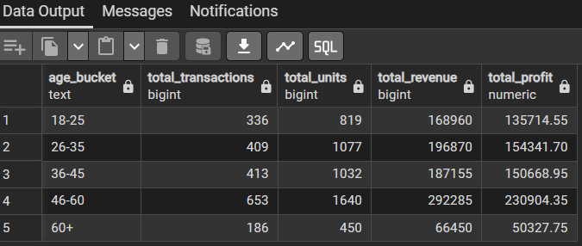
Gender & Category Analysis
- Analyzed revenue distribution by gender across product categories
- Determined category preferences for male and female customers
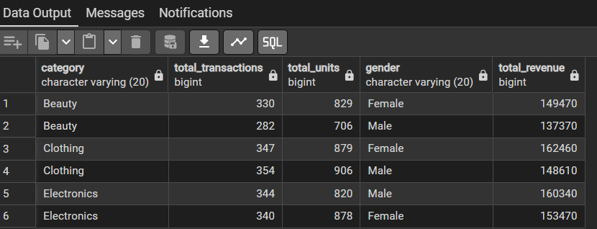
Peak Sales Time Analysis
- Evaluated sales performance hourly
- Identified peak revenue hours and loss-making time slots
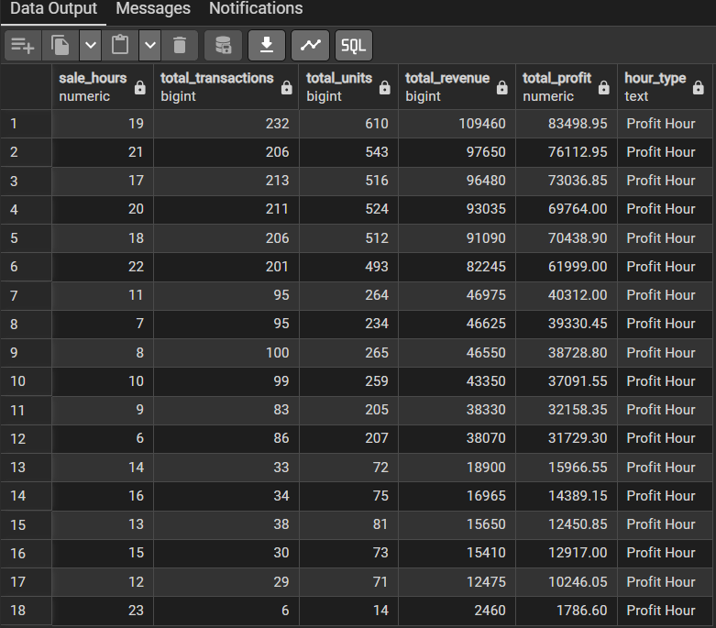
Monthly Sales Trend Analysis
- Analyzed month-wise revenue and profit trends
- Identified best and worst performing months
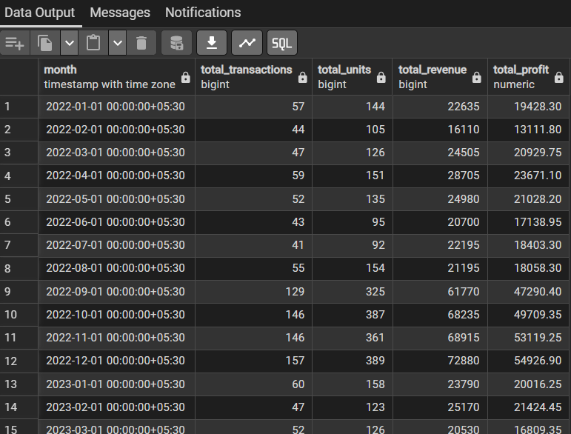
Category Performance Analysis
- Calculated total revenue, total profit, and profit margin per category
- Highlighted top-performing and low-performing categories
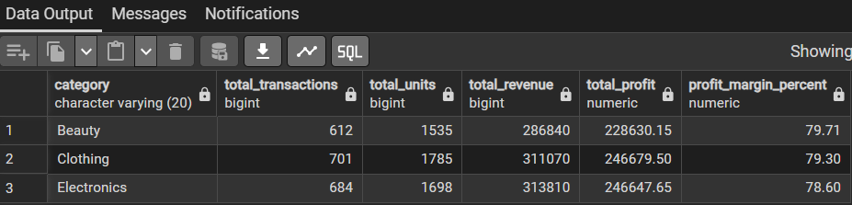

5. Ad-hoc / KPI Analysis
Overall Business Performance:
- Total revenue, total cost, total profit, overall profit margin
- Provides high-level business snapshot
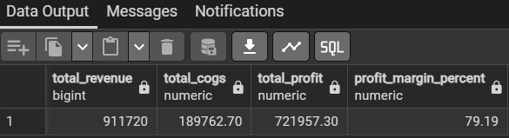
Best & Worst Categories:
- Top 3 and bottom 3 categories by total profit
- Helps prioritize areas for growth and improvement
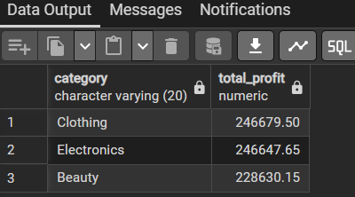
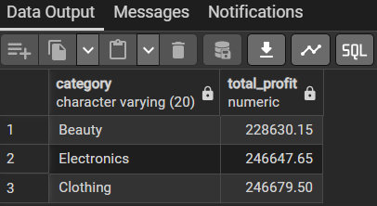
Customer Retention Analysis:
- Calculated percentage of repeat customers
- Measures customer loyalty
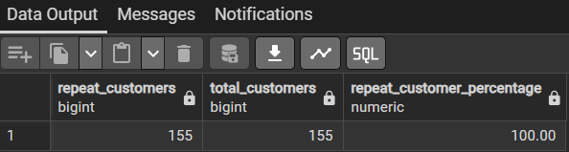
High-Value Customers:
- Top 10 customers based on total revenue and profit
- Supports targeted marketing and loyalty programs
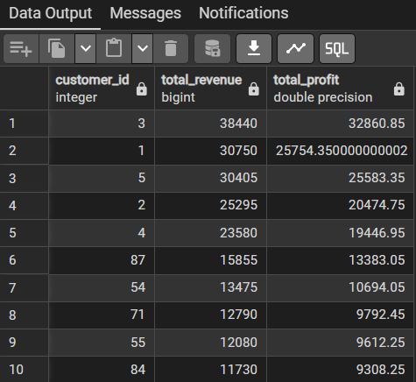
Best & Worst Month Analysis:
- Highest and lowest performing months by revenue
- Useful for seasonal planning and promotions
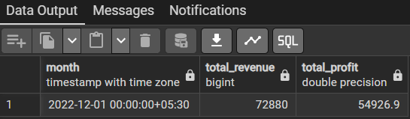
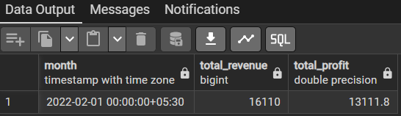
Preferred Category by Gender:
- Most preferred product category for each gender
- Helps design gender-specific marketing campaigns
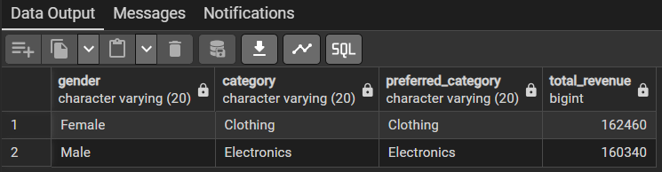

6. Dashboard in Power BI
- Built an interactive dashboard for visual representation of insights
- Key metrics, trends, and comparisons displayed visually for decision-making
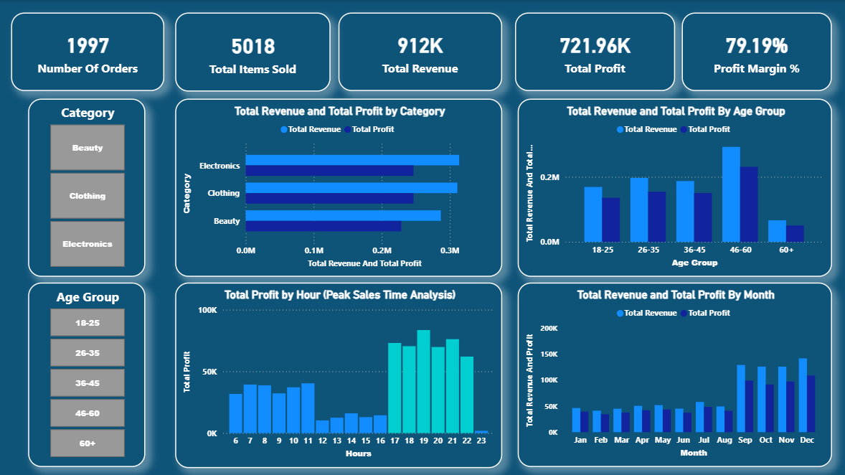

7. Business Recommendations
Key Insights:
- Boost Subscriptions: Promote exclusive benefits
- Loyalty Programs: Reward repeat buyers
- Discount Policy: Balance sales and profit (~79% margin)
- Product Positioning: Highlight top-selling categories
- Targeted Marketing: Focus on high-revenue age groups & peak hours

